Code and its result

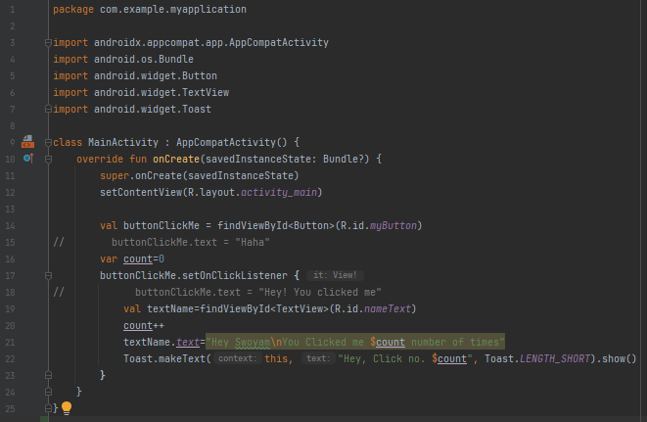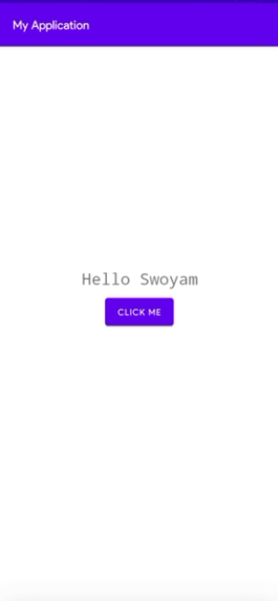

  
The above loads the content view made from the XML File

  
In the XML file, we have give the button and id of **myButton**, now we are creating a connection link between the **Kotlin Code** and the button through the given code. All the further edits with the button can be done through code with the help of the **Connecting Variable**

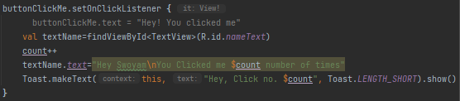  
Here, we’ve used the **Connecting Variable** to define and declare the actions that should be done when the user clicks the button. It is also a great example of how we can use **Connecting Variables** for controlling the Button and its uses

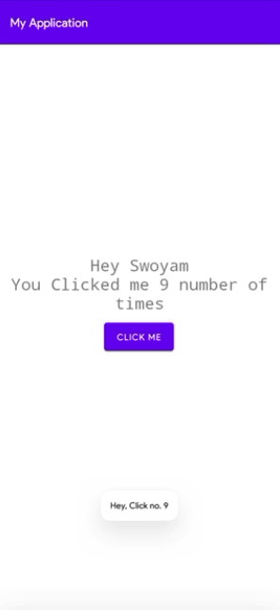  
This is an example of creating a toast. Refer to the code to analyze how we are controlling the text that is to be shown in the toast

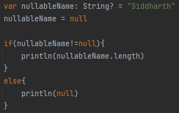

This is how nullables are used in kotlin.  
There is an alternative method of writing the above code which is

